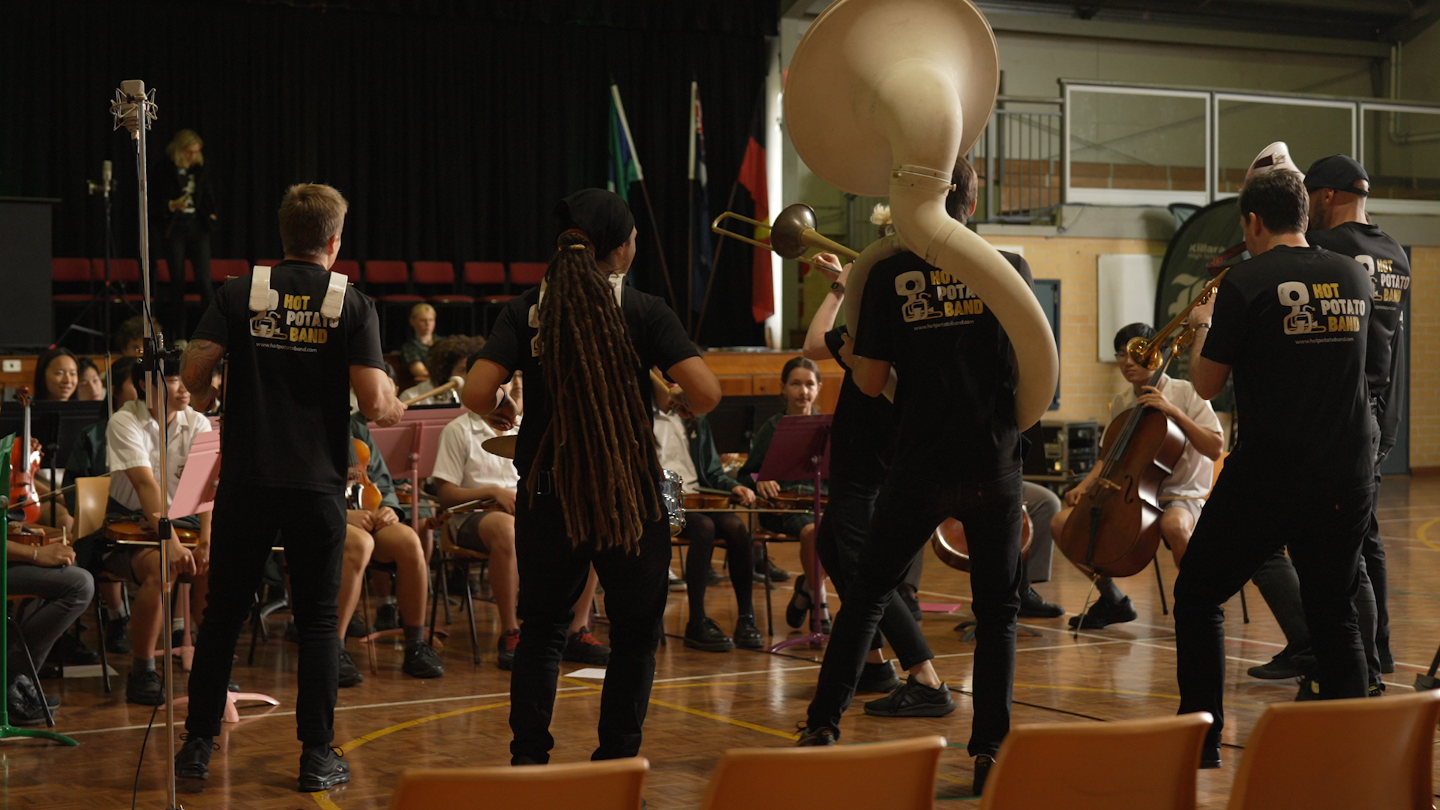

Sennheiser and Neumann Microphones are an “Absolute Game Changer” for Sydney’s Hot Potato Band

By embracing Sennheiser’s EW-DX wireless microphones system and Neumann’s Miniature Clip Microphones, the nine-piece brass ensemble Hot Potato Band has not only elevated their performances from the street to the stage, but deepened connections with their fans and students, too.

Sydney, Australia, 11 April 2024 – The impressive nine-piece brass band, Hot Potato Band has been using Sennheiser and Neumann equipment as an integral part of their live gigs and school workshops. Neumann and Sennheiser were fortunate enough to speak with Simon Ghali, the Founder and band leader of Hot Potato Band and Pete Orenstein, the Director of Hot Potato Band in Schools Program and the band’s saxophone player about their experience with the audio solutions. Having been playing together since 2009, beginning as a New Orleans inspired roaming band on the street, the group has since expanded to playing since expanded to writing and touring original music alongside their educational initiative of performing in schools and providing workshops. Wireless audio systems like Sennheiser’s Evolution Wireless Digital family – particularly the EW-DX – and the Neumann Miniature Clip Microphone System (MCM) have enabled them to move freely in their performances, wherever they play, without worry.

As a group that got their start with dynamic, organic street performances, Pete and Simon's journey into utilising wireless microphones began with a desire to bring the vibrancy of their acoustic busking performances onto the stage. Pete recalls, "We had our first show with a lot of wired microphones and sound setups, which restricted our movement. We couldn't bring the same energy we were known for. That's when I suggested, 'Why don't we get some wireless mics?' We wanted to create the same spirit and atmosphere we had on the street in our acoustic format." This realisation marked the beginning of their exploration into wireless technology, looking for a way that gave them the freedom to move without sacrificing sound quality.

The Seamless Magic of Sennheiser Wireless Audio
In the band’s journey, they eventually landed on the Sennheiser EW-DX wireless systems. According to Pete, the EW-DX has been “really incredible” technology for the band. They are impressed by the consistent performance of Sennheiser’s latest wireless microphone solution, even in unconventional venues with RF signal challenges. Simon echoed Pete’s sentiment, praising how Sennheiser gear effortlessly integrates into their gigs, “The technology isn't obvious, and that's the magic of it – whether it's attaching onto a sax or grabbing a wireless mic, They're free to rock the stage or classroom”.

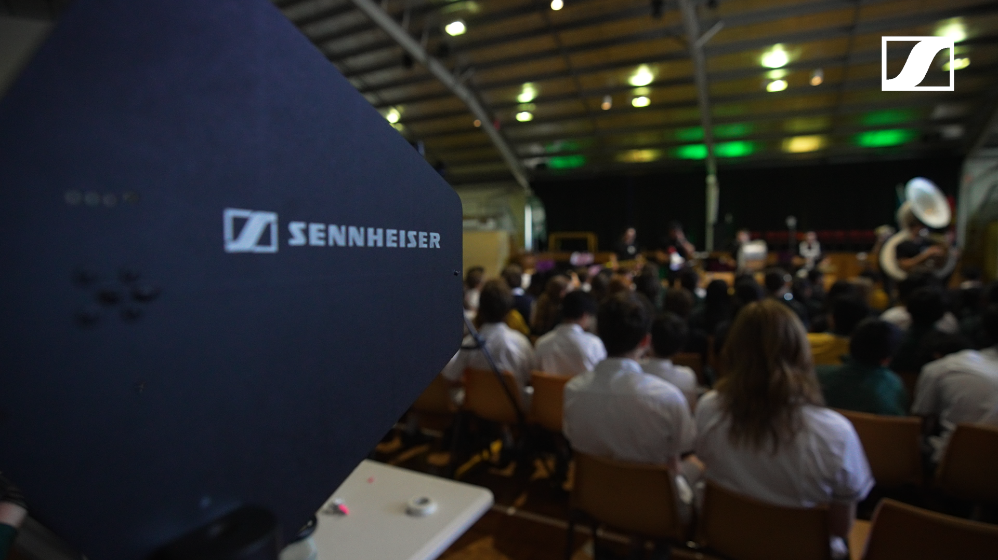Equipped with Sennheiser and Neumann equipment, Hot Potato Band are giving the students a live demonstration at Killara High School.

With Sennheiser's "plug and play" functionality, the band can effortlessly integrate their equipment, allowing them to focus solely on delivering exceptional performances without any technical distractions. Where it used to take the band about 90 minutes every gig to set up the tech, it has now gotten a lot faster, with their quickest set-up being at 20 minutes – this is impressive for any artist, let alone a nine-piece band.

Sennheiser's reliability has been so consistent for the band that the concept of technology has become invisible. Rather than fixating on the technology itself, it's all about the seamless execution. Pete expressed his astonishment, saying, "I can't believe how quick it is for us to get on a stage and play these days... and when the tech can all work seamlessly together. It’s just amazing."

Pete and Simon emphasise how technology can be a game-changer for musicians. As Pete states, "Technology is an enabler for us to tell that story." It's not about flashy gadgets—it's about using the right tools to tell your story and connect with your audience. Their journey shows how technology has been vital in enhancing their storytelling and performance setup, without overshadowing their artistic vision. Advances in technology such as monitoring systems have streamlined processes, making life easier for the band members, and elevating their collective musical experience to new heights.

From the Stage to School, with Neumann
Neumann’s new line of Miniature Clip Microphones for close-miking instruments have been transformative for the band, especially in their performances at school programs. Simon reflects on how the low-profile, clip-on microphones enabled them to maintain their New Orleans-like street band identity, stating "We faced a challenge because we love to move around on stage. Wireless technology became our solution. It enabled us to maintain our identity as roaming musicians while performing on stage."
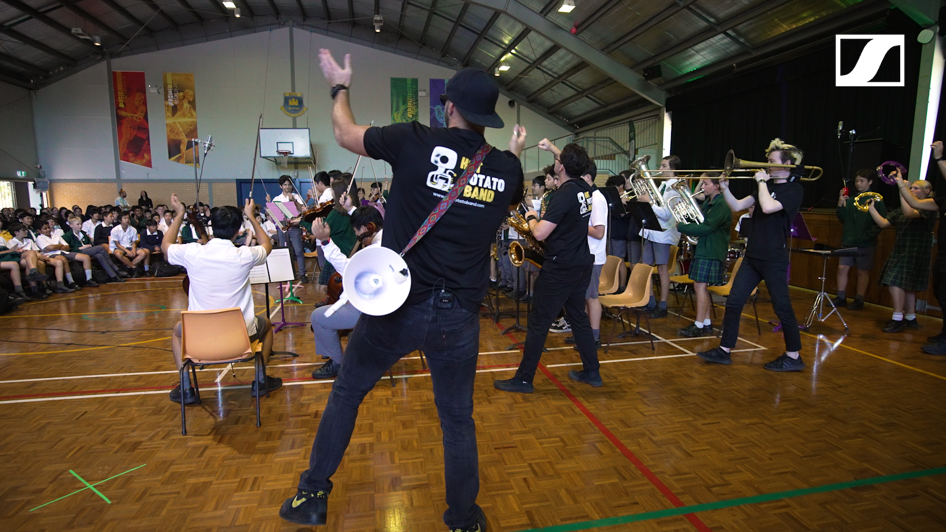
The Hot Potato Band brings a lively energy to the Killara High School students during their Workshops & School Concerts program, cheering and playing music alongside them.

The Hot Potato Band Workshops & School Concerts program was a natural progression for the band, and they found themselves engaging with their local communities while responding to invitations from schools. Simon explains, "We didn't plan it, but the community directed us. Schools asked, 'Can you come?' And we said yes”. After the pandemic, they noticed a lot of arts programs were cut from schools, and discovered a massive need not only to inspire students but offer the skills and knowledge that come from playing live music. “So, we started offering workshops and teaching them skills we learned on stage, like how to put on a gig. Our close connection with fans guided us through this path, and now, we collaborate with schools to bring music and inspiration to students."

Pete shares his enthusiasm for Neumann’s MCMs, particularly praising their quality in the studio and during performances. With six MCMs in the band’s setup, he describes the MCM as "fantastic for live performance", thanks to their beautiful capsule that adds a unique sizzle and ensures they blend effortlessly into the mix. Plus, with the KK 13 (omni) and KK 14 (cardioid) capsules as options, they capture the distinct sound of each unique instrument flawlessly. Simon shares Pete's enthusiasm, emphasising the reliability of this setup and how great it is.

The MCM System's versatility has been crucial for their nine-piece brass band, offering nine instrument-specific mounting clips tailored for various acoustic instruments. These clips provide straightforward and dependable mounting options, easily positioned on any instrument. Pete especially praises the MCM 114’s durability and its ability to stay in place throughout lively performances with various instruments in the band, like the saxophone, percussion instruments, trombone and trumpets. He even notes, "Where you set it at the beginning of the show is where it stays till the end."

Inspiring the Next Generation of Musicians
Pete and Simon's work is nothing short of inspiring, not only for the students they work with but also for themselves. Their hands-on approach yields immediate results, with even initially disinterested students leaving eager to play more. The workshops' structure accelerates learning, with students quickly improving and feeling confident. Recently, Hot Potato Band collaborated with Sennheiser to film a dynamic School Program episode at Killara High School, delivering an engaging music experience and a memorable performance for the entire school.

Before starting these workshops, Pete had spent eight years as a full-time teacher, so he knows firsthand the impact they can have and how much they’ve contributed to their musical journey. Over time, they've seen former students go on to study music at the Conservatory of Music, join bands and even come back to collaborate with them. Pete says, "It's quite amazing to watch and be able to perform with them," showing how proud they are of their students' success.
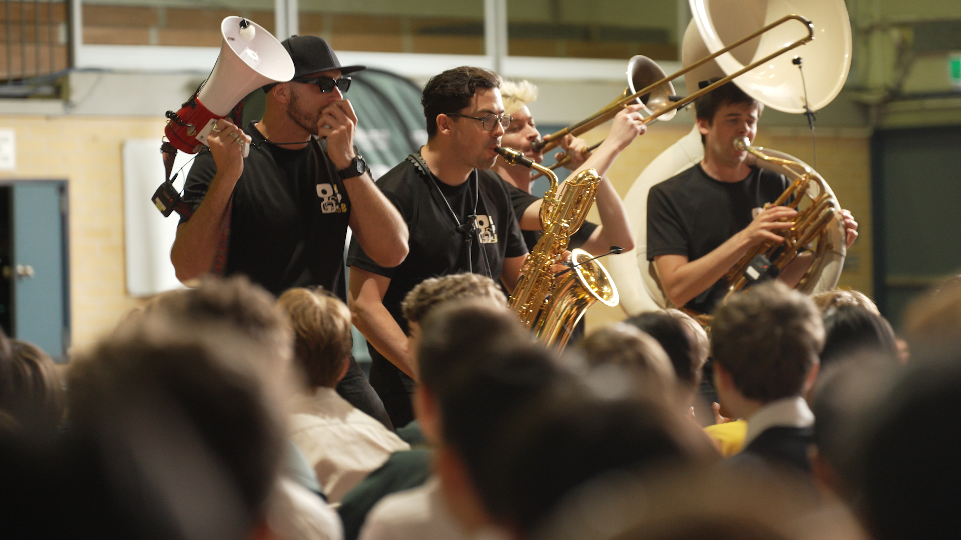
At Killara High School, Hot Potato Band performed with the MCM attachment on the saxophone, trombone, and sousaphone during their workshop.

Their goal goes beyond just teaching music; it's about sparking a love for it that lasts a lifetime. While recognising their approach isn’t the only one, they aspire to cultivate curiosity and enthusiasm in their students’ path in music. As Simon quotes American jazz legend Herbie Hancock, "Life is music, and music is life," echoing the sentiment to live fully and be curious. He adds, “have music as something that doesn’t only gets you through life but enhances it tremendously. This way, you will have the best experiences, for the music can take you all around the world.” Hot Potato Band want to encourage students to let music enrich and enhance their lives in whatever form that may take, whether as a performer, teacher, or simply a passionate enthusiast.

Leveraging seamless integration of wireless audio technologies, the band has been on transformative tours, captivating audiences with energetic gigs, and engaging students through collaborative workshops in schools across Australia. Hot Potato Band heads off for a European tour in June 2024, with their trusted Sennheiser and Neumann audio equipment in tow.

For more information on upcoming shows, music and recent projects, visit: https://www.hotpotatoband.com/

About the Sennheiser Group
Building the future of audio and creating unique sound experiences for our customers - this is the aspiration that unites the employees of the Sennheiser Group worldwide. The independent family-owned company Sennheiser was founded in 1945. Today, it is managed in the third generation by Dr. Andreas Sennheiser and Daniel Sennheiser and is one of the leading manufacturers in the field of professional audio technology.
sennheiser.com | neumann.com | dear-reality.com | merging.com

Local Press Contact  Daniella Kohan  daniella.kohan@sennheiser.com  +1 (860) 222-4226 | Hotwire Australia  sennheiseranz@hotwireglobal.com

